

Student Details
STUDENT NAME: FAITH MWENDE
ADMISION NUMBER: BSCCS/2024/61503
COURSE/CLASS: COMPUTER SCIENCE
UNIT CODE: BIT3208
UNIT NAME: ADVANCED WEB DESIGN
LECTURER NAME: MICHAEL NYORO
SEMESTER/ACADEMIC YEAR:3.2

Project Details
PROJECT TITLE: THIKA ACADEMY SCHOOL MANAGEMENT SYSTEM
SELECTED TECHNOLOGIES: PHP +MySQL, JAVASCRIPT
GITHUB REPOSITORY LINK: https://github.com/camwee/ADVACED_WEB_PROJECT

Table of Content
Table of Contents
 1
Student Details 1
Project Details 1
Week 1: Local Environment Setup 4
Title 4
Installation and Testing of Local Development Environment 4
: Installation of XAMPP 4
Apache and MySQL Running 5
Localhost Test Page 5
Hello World Test 6
Database Connection Test 6
Week 2: Wireframes and GUI Design 7
Title 7
User Interface Planning and System Design 7
Fig 1: Hand-drawn Wireframe 7
Fig 2: Dashboard Layout Design 8
Week 3: JavaScript and PHP Basics 10
Password Strength Checker 10
Week 4 14
Login form screenshots 14
PHP processing screenshots 15
Database connection screenshots 16
Week 5 16
Table creation screenshots 16
CRUD operation screenshots 17
Login database integration screenshots 17
SQL query screenshots 19

Week 1: Local Environment Setup

Title

Installation and Testing of Local Development Environment

Installation of XAMPP

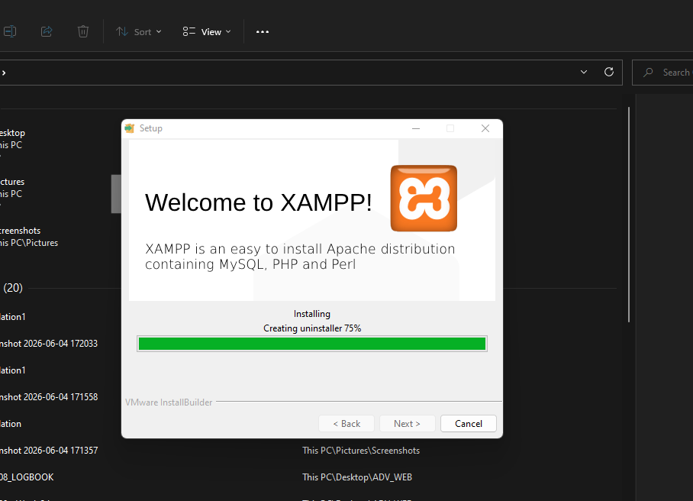
This screenshot shows the installation of xampp

Apache and MySQL Running
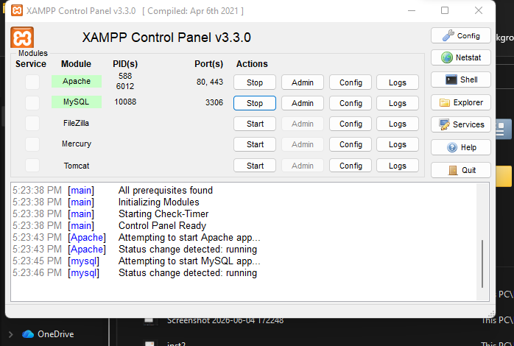
This screenshot shows the Apache and MySQL running

Localhost Test Page
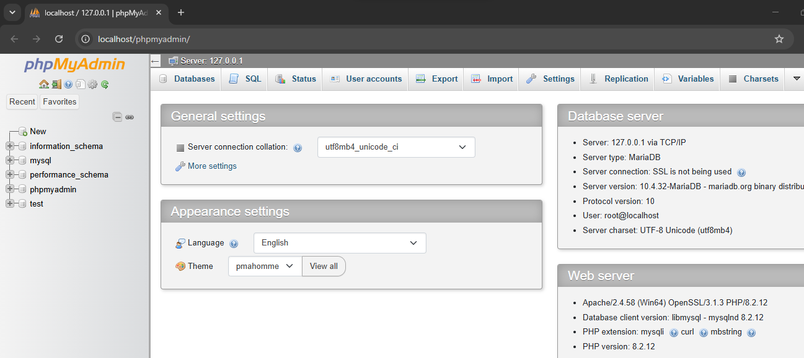
This screenshot shows the localhost test page running successfully

Hello World Test
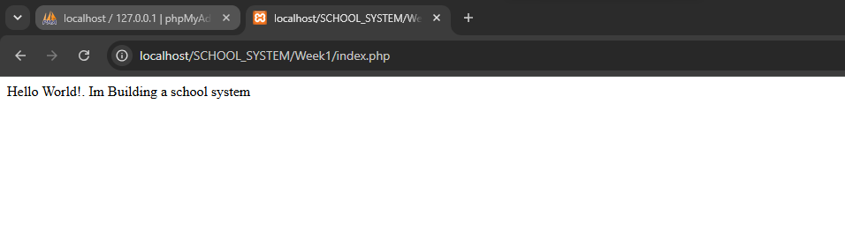
This screenshot shows the output of the php webpage

Database Connection Test
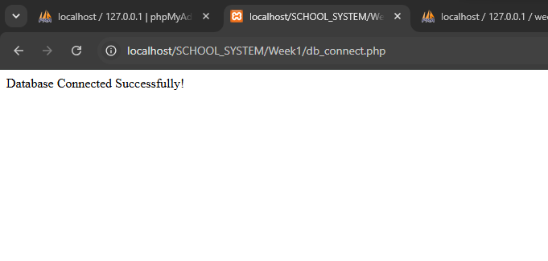
This screenshot shows successful connection of the database to the frontend section

Week 2: Wireframes and GUI Design

Title

User Interface Planning and System Design

Fig 1: Hand-drawn Wireframe
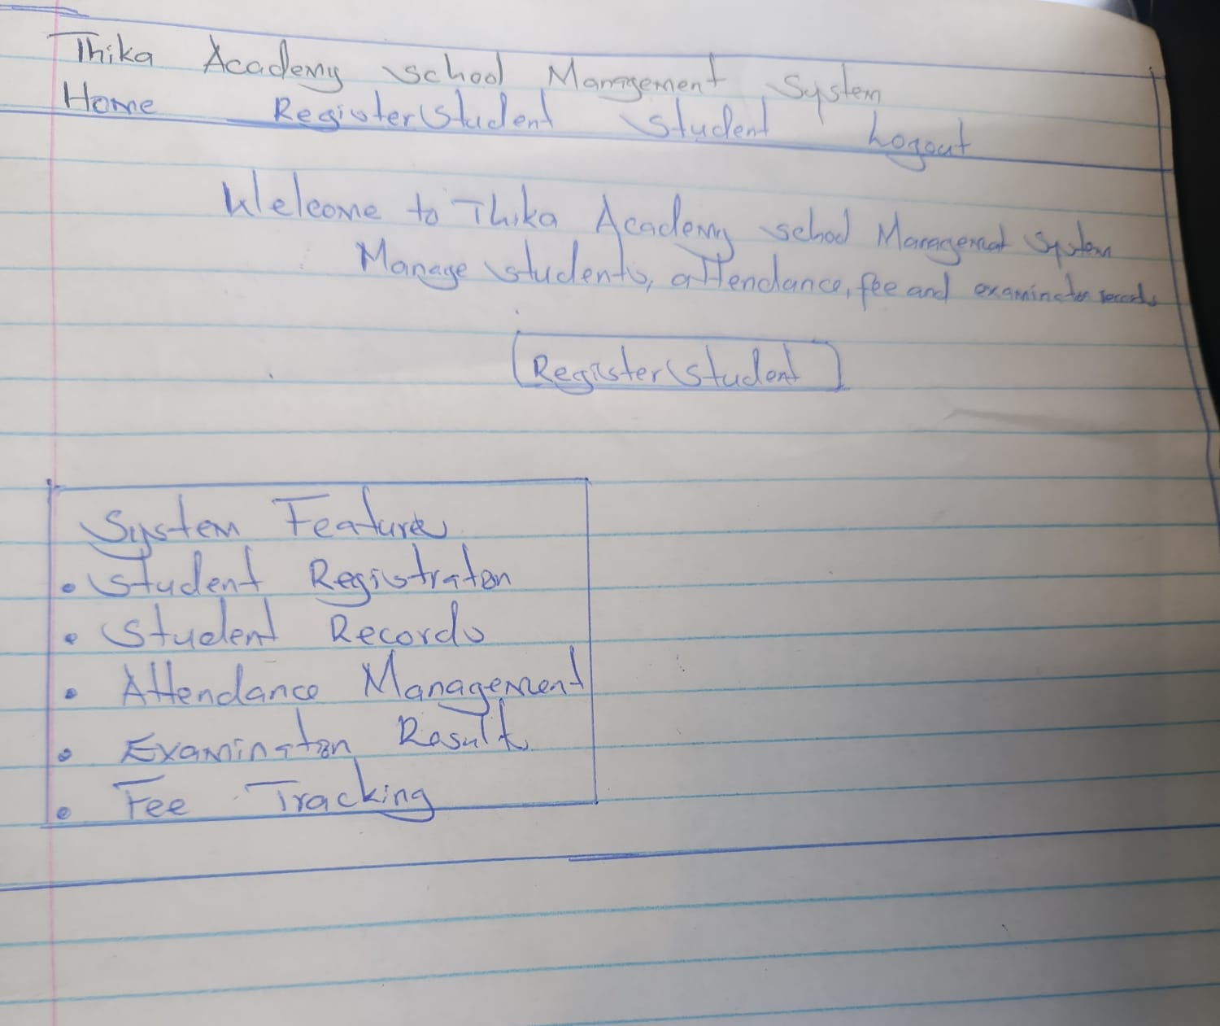
This is the hand drawn wireframe of the dashboard layout

Fig 2: Dashboard Layout Design
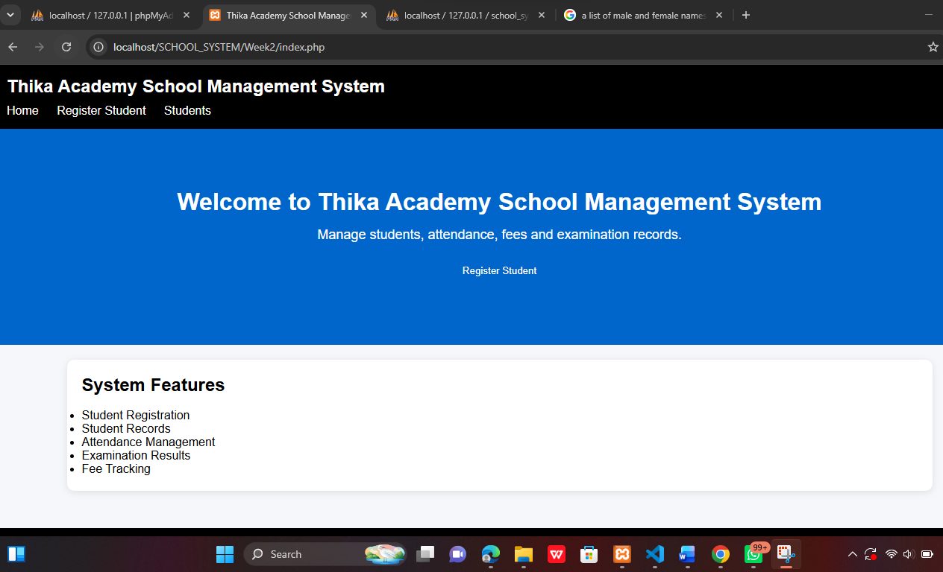
This is the screenshot of the Dashboard layout

Mobile View Mockup
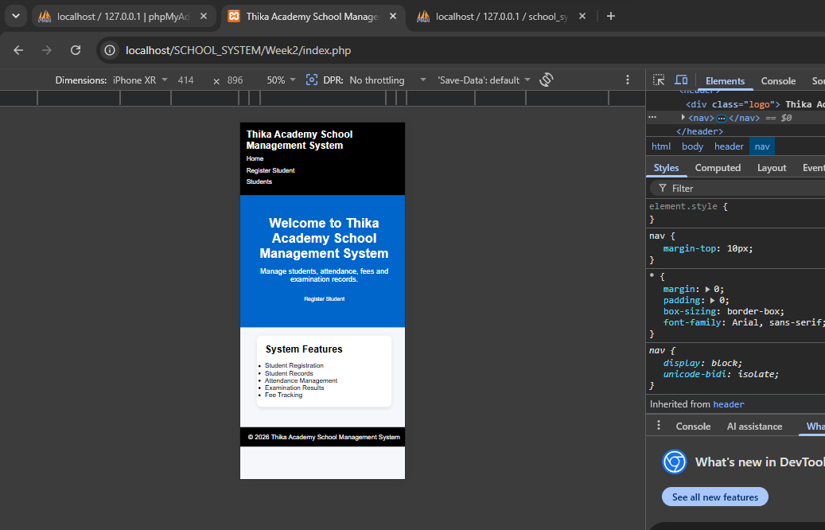
This Screenshot shows the mobile responsiveness of the system opened using the inspect feature

Color Theme and Navigation Structure
The color theme is black, blue and white
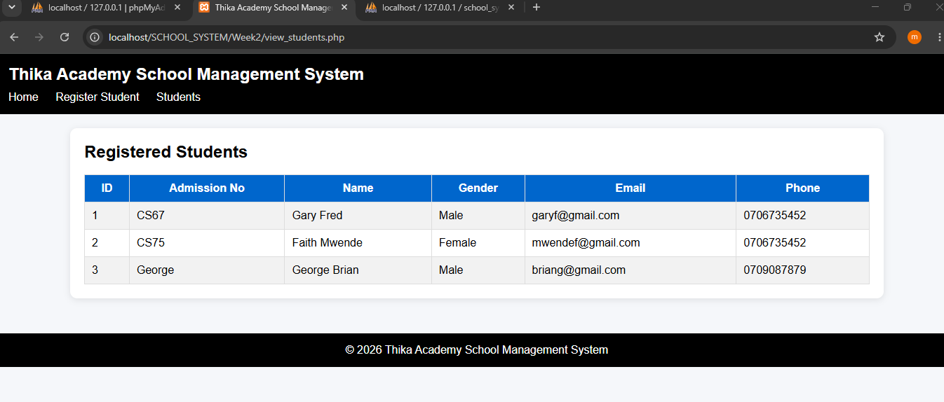

Week 3: JavaScript and PHP Basics
JavaScript Form Validation
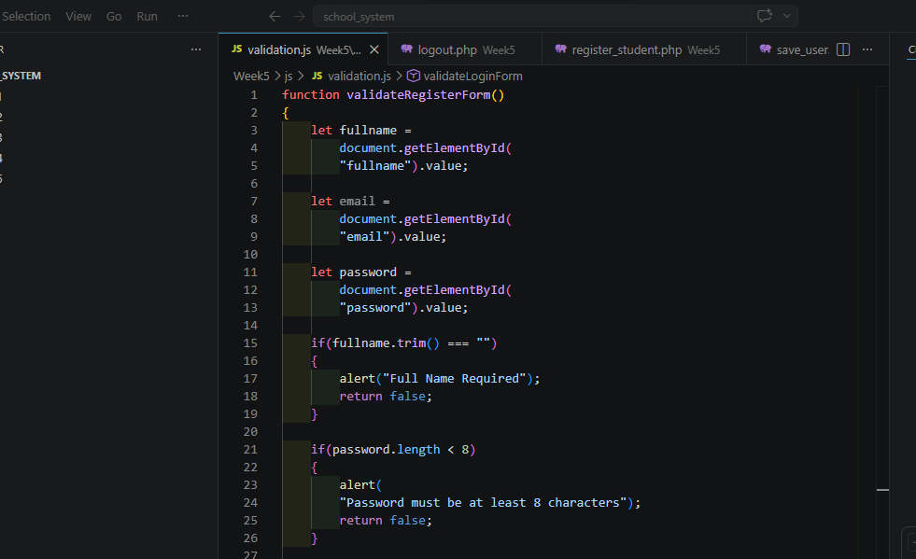
This is the Javascsript form validation code

Password Strength Checker
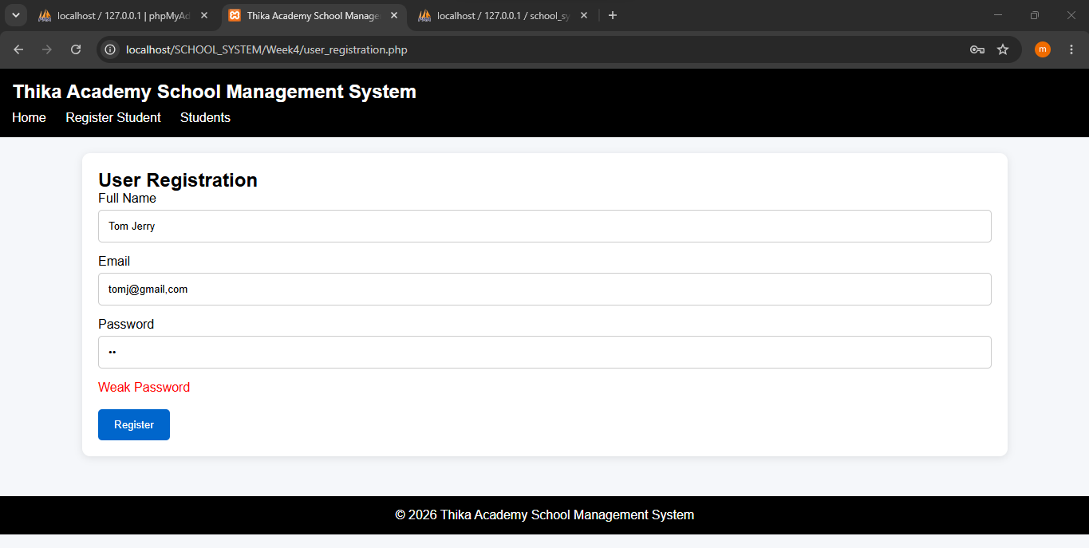
This screenshot shows the Password strength checker that alerts the user when typing their password if its weak, medium or strong

PHP Syntax Practice
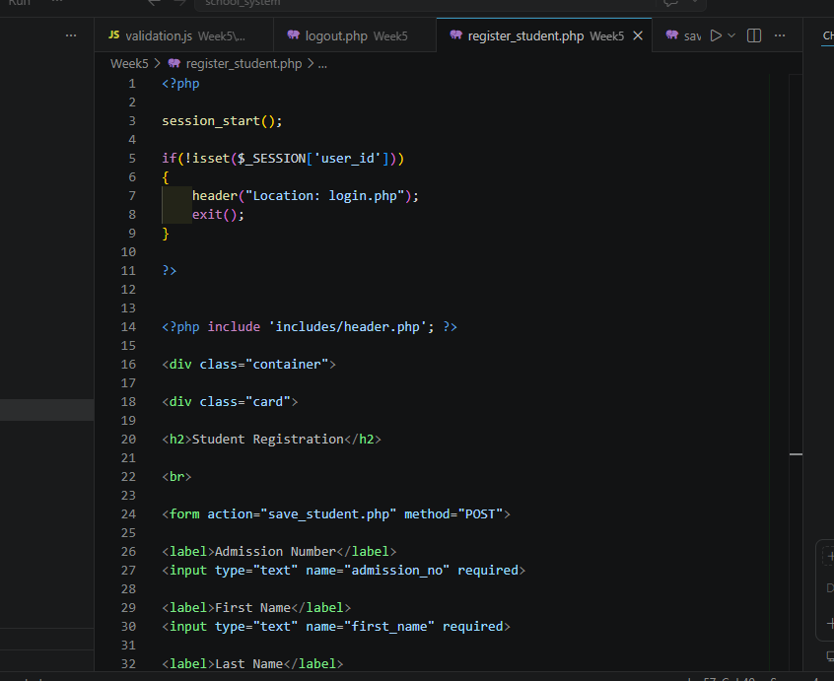
This is the php syntax of the register_student.php

Database Connection Script
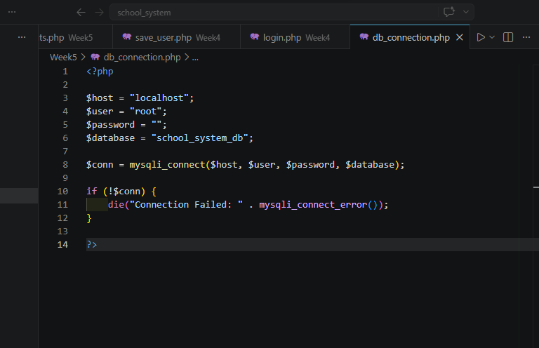
This is the database connection script that provides the connection between the frontend and the database

Week 4

Login form screenshots
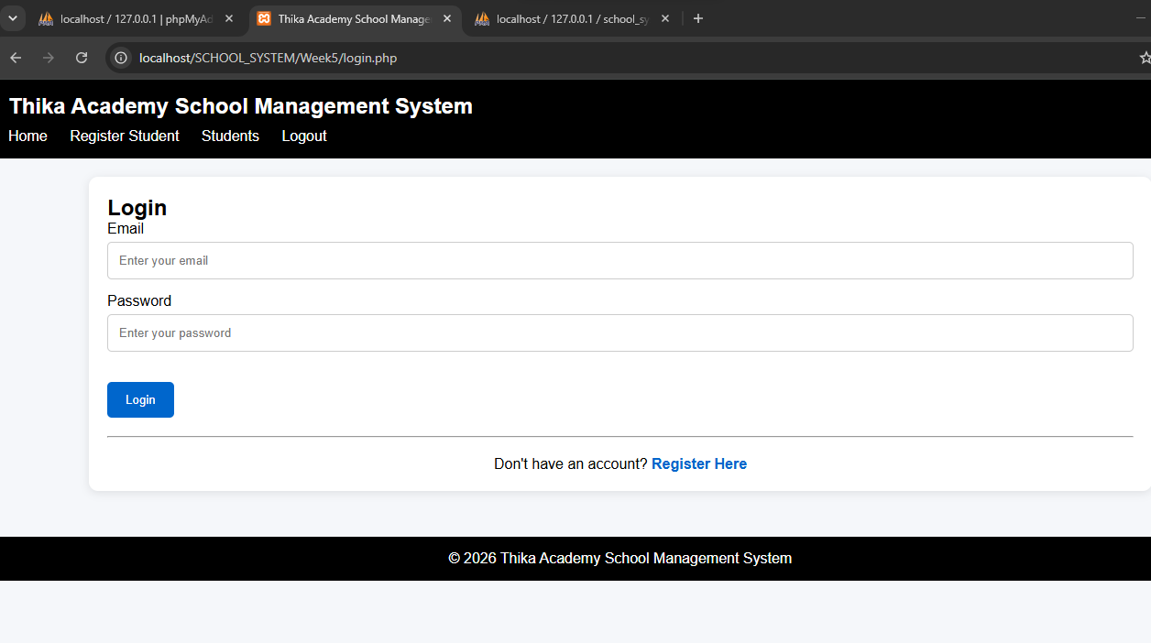
This is a screenshot of the login form

PHP processing screenshots
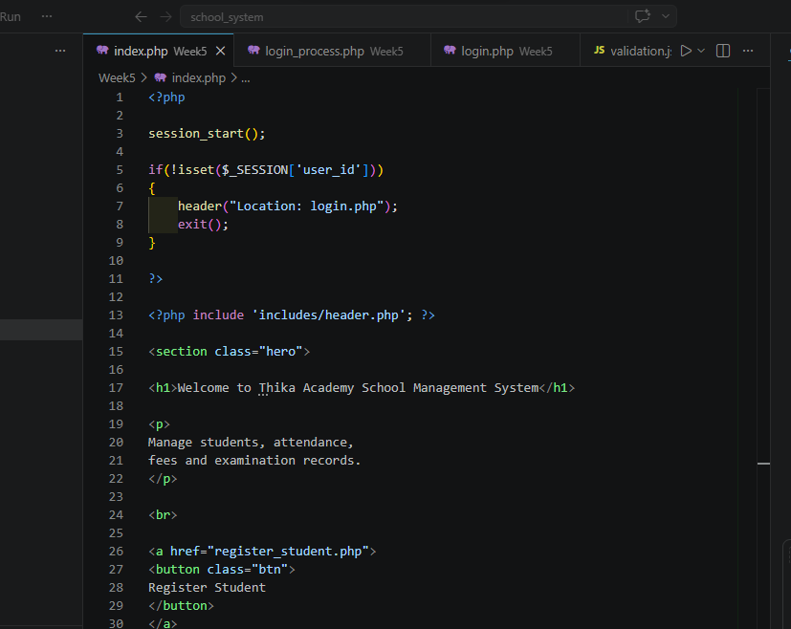
This is a screenshot of php processing in the index.php file

Database connection screenshots
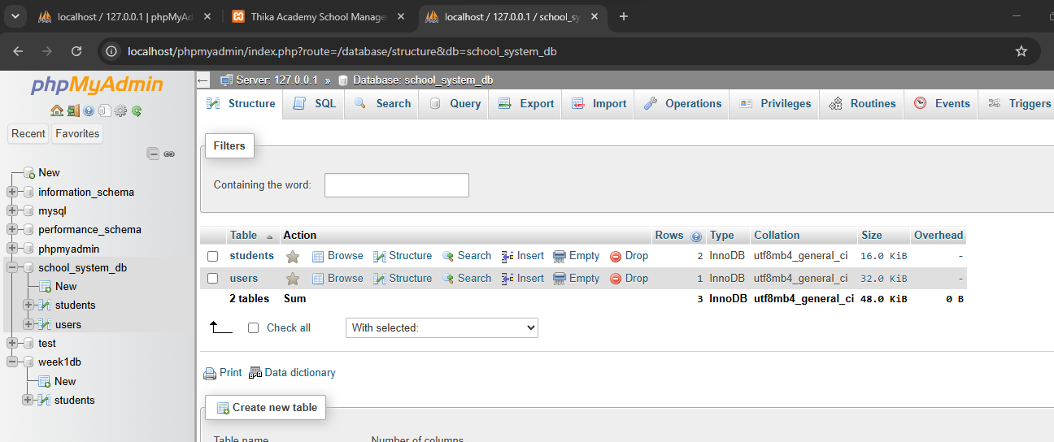

Week 5

Table creation screenshots
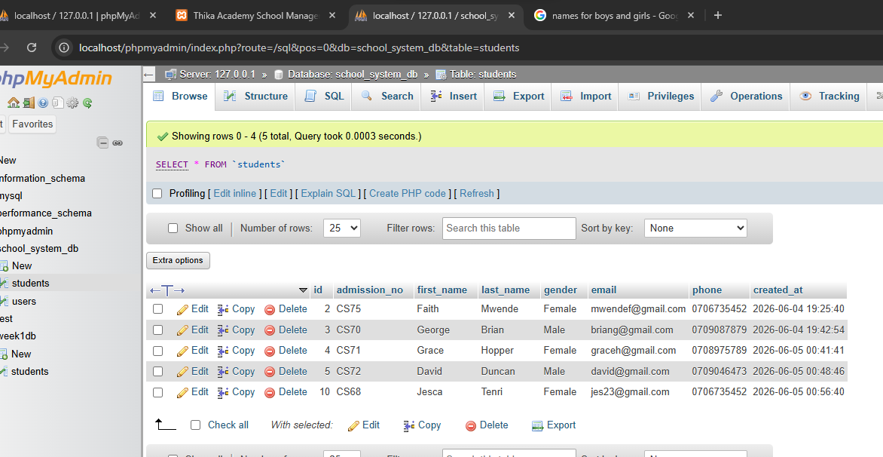
This is a screenshot of the tables in MySQL

CRUD operation screenshots
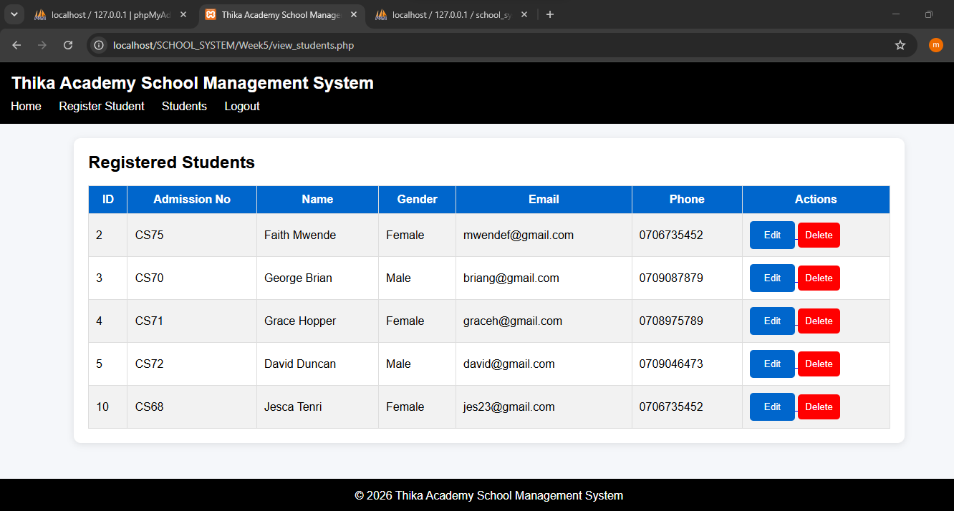
This is a screenshot of a working CRUD, A student can be added, read, updated by editing and can also be deleted

Login database integration screenshots
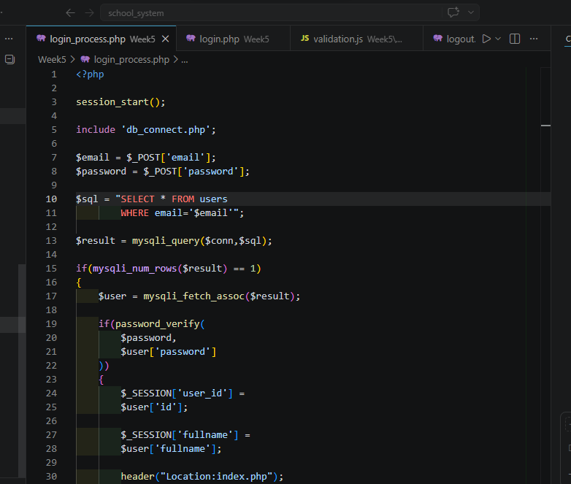
This screenshot shows the login database integration process

SQL query screenshots
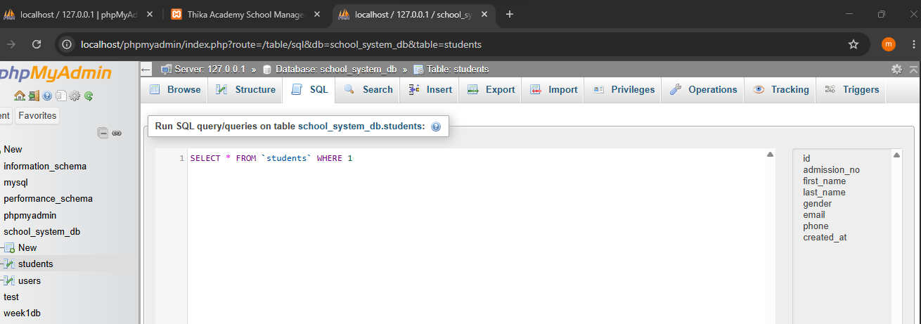
This screenshot shows the SQL section that enables automatic table creation by entering commands

